Knowing if an element is a block level element or an inline level element helps you to determine the position of the element within your document. It helps you to know if it is going to stack on top of the another element or be beside another element.

Block Level Elements:
- Block level elements start on a new line. The browser automatically adds space before and after the element (margin). They stack like blocks on top of each other and take up the width of the entire page. (Stretches out to the left and right as far as it can)

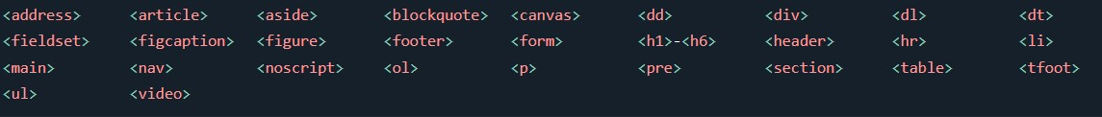
Inline-Level Elements:
- An inline element does NOT start on a new line and only takes up as much room as necessary.

